**Selenium Hands-on:**

**Drop down:**

QUESTION 1

----------

URL : http://toolsqa.com/automation-practice-form/

NOTE: print all the option continents.

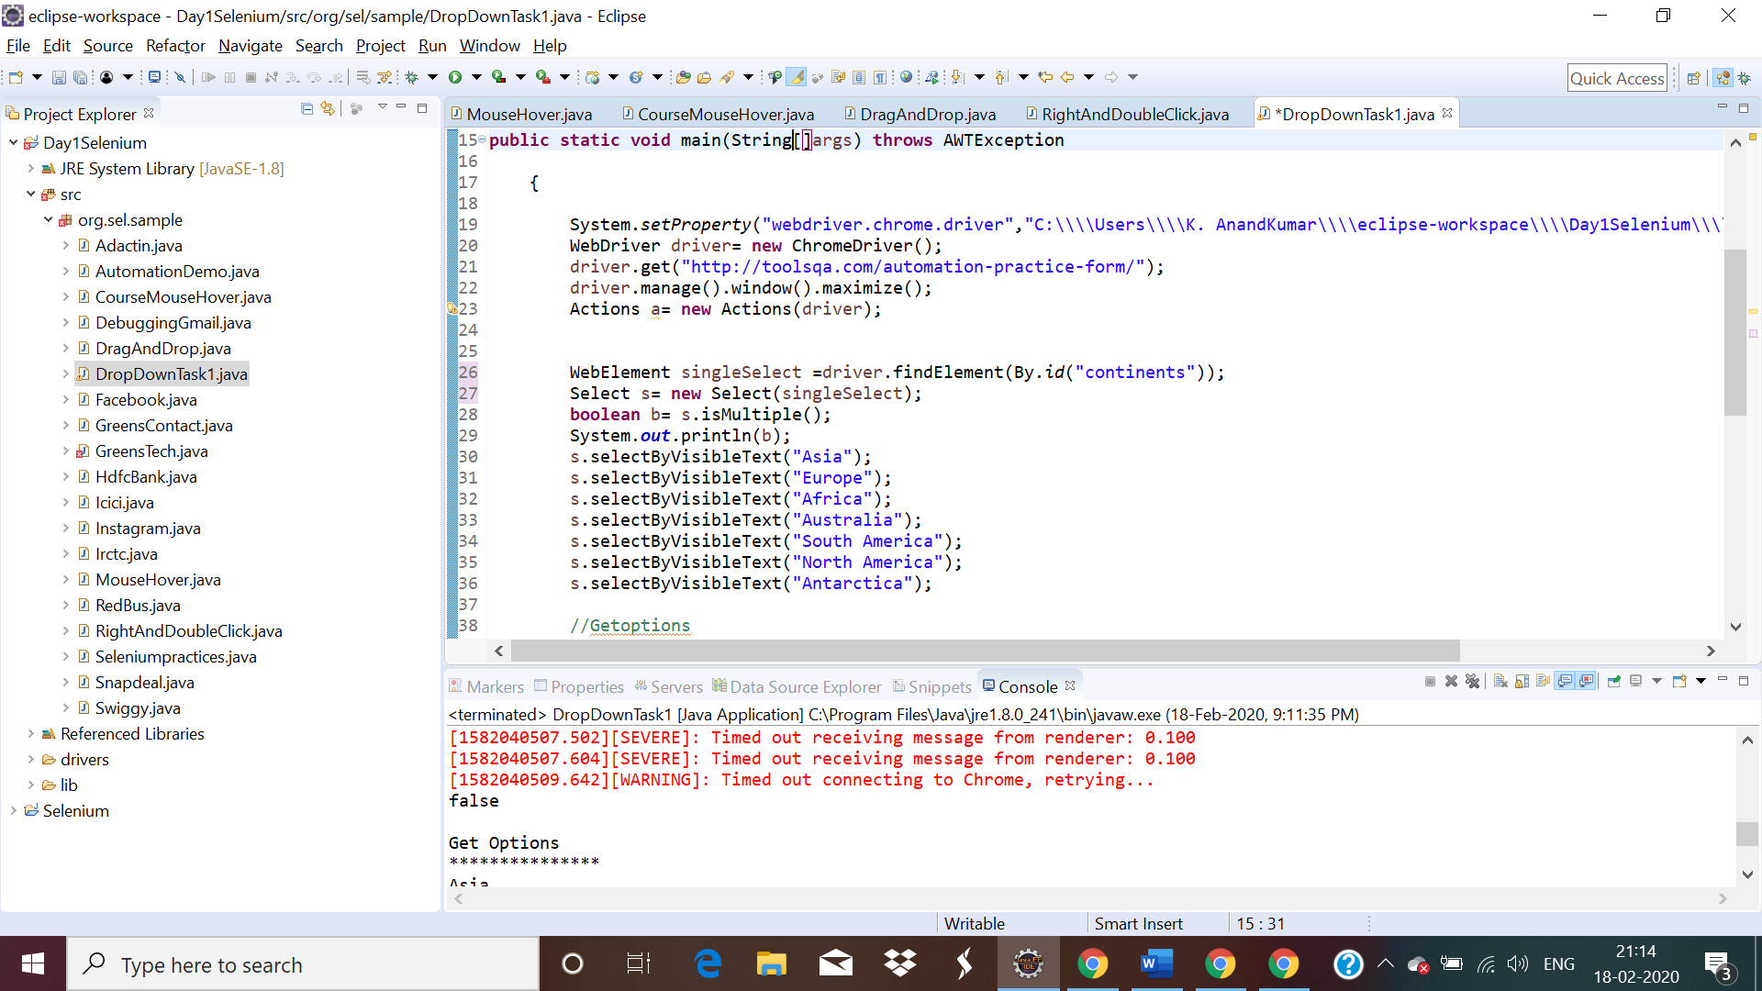

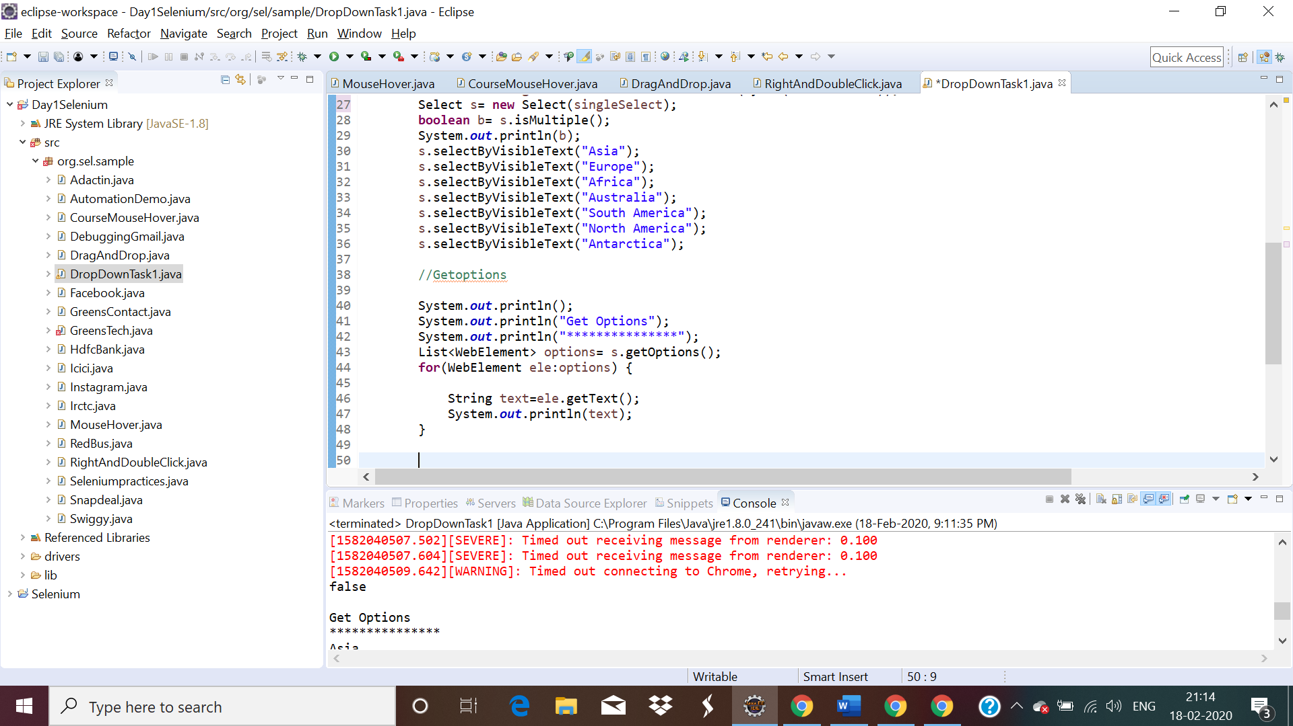

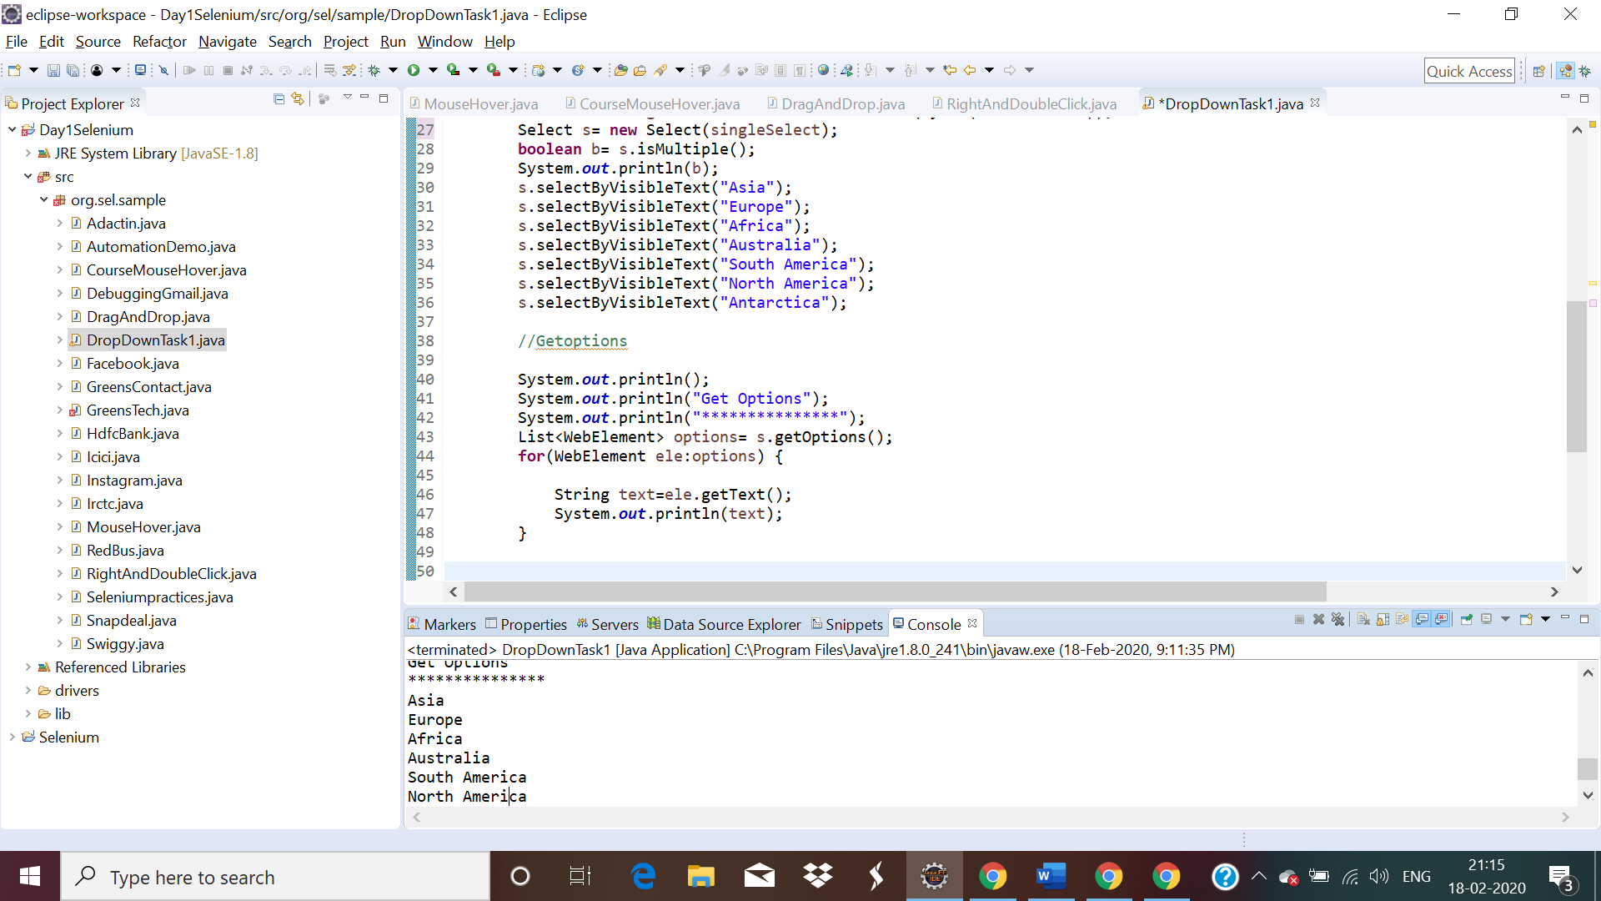

Multi select:

QUESTION 2

----------

URL : http://toolsqa.com/automation-practice-form/

NOTE: print all the odd option in selenium commands.

